##quize 1.1 Answer for sql for data science

1.Question 1

Select the jobs below that may use SQL in their work (select all that apply).



Backend Developer

**Correct**

See the video entitled, "What is SQL Anyway?" for more information.



DBA

**Correct**

See the video entitled, "What is SQL Anyway?" for more information.



Data Scientist

**Correct**

See the video entitled, "What is SQL Anyway?" for more information.



Data Analyst

**Correct**

See the video entitled, "What is SQL Anyway?" for more information.



QA Engineer

**Correct**

See the video entitled, "What is SQL Anyway?" for more information.

**1 / 1 point**

2.Question 2

How does a data scientist and DBA differ in how they use SQL?



Data scientists don’t write complex queries.



DBA’s are the only ones who merge datasets together.



Data scientists only query the database and don’t create tables.



DBAs manage the database for other users.

**Correct**

See the video entitled, "What is SQL Anyway?" for more information.

**1 / 1 point**

3.Question 3

Which of the following statements are true of Entity Relationship (ER) Diagrams?



They identify the Primary Keys

**Correct**

See the video entitled, "Data Models, Part 2: The Evolution of Data Models" for more information.



They usually are represented in a visual format.

**Correct**

See the video entitled, "Data Models, Part 2: The Evolution of Data Models" for more information.



They show you the relationships between tables.

**Correct**

See the video entitled, "Data Models, Part 2: The Evolution of Data Models" for more information.



They only represent entities in the diagram.



They speed up your querying time.



They are usually a representation of a business process.

**Correct**

See the video entitled, "Data Models, Part 2: The Evolution of Data Models" for more information.

**1 / 1 point**

4.Question 4

Select the query below that will retrieve all columns from the customers table.





1

SELECT (*) FROM customers





1

2

3

4

5

6

7

8

9

SELECT

FirstName

,LastName

,Address

,City

,State

,ZipCode

,PhoneNumber

FROM customers





1

RETRIEVE * FROM customers





1

SELECT * FROM customers

**Correct**

See the video entitled, "Retrieving Data with a Select Statement" for more information.

**1 / 1 point**

5.Question 5

Select the query that will retrieve **only** the Customer First Name, Last Name, and Company.





1

2

3

4

5

6

SELECT

FirstName

,LastName

Company

FROM customers





1

SELECT * FROM customers





1

2

3

4

5

6

SELECT

FirstName

,LastName

,Company

FROM customers





1

2

3

4

5

6

SELECT

FirstName

LastName

Company

FROM customers

**Correct**

See the video entitled, "Retrieving Data with a Select Statement" for more information.

**1 / 1 point**

6.Question 6

The ER diagram below is depicting what kind of relationship between the **EMPLOYEES** and **CUSTOMERS**tables?

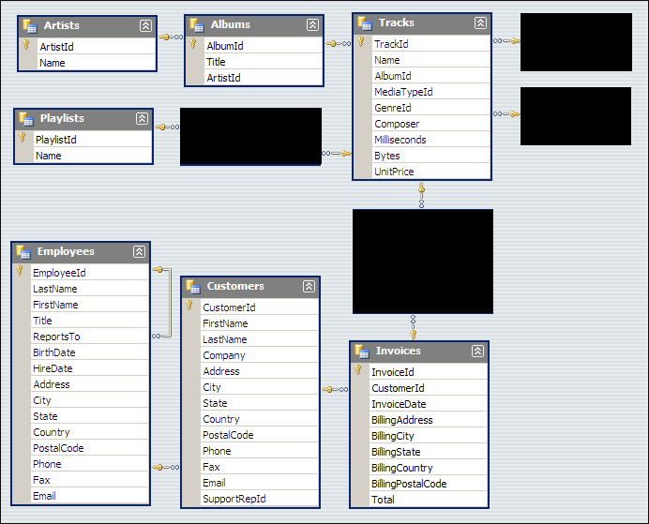



One-to-one



One-to-many



Many-to-one



Many-to-many

**Correct**

See the video entitled, "Data Models, Part 3: Relational vs. Transactional Models" for more information.

**1 / 1 point**

7.Question 7

The data model depicted in the ER diagram below could be described as a _______________.





Relational Model



Star Schema



Transactional Model

**Correct**

See the video entitled, "Data Models, Part 3: Relational vs. Transactional Models" for more information.

**1 / 1 point**

8.Question 8

When using the "CREATE TABLE" command and creating new columns for that table, which of the following statements is true?



You must insert data into all the columns while creating the table



You can create the table and then assign data types later



You must assign a data type to each column

**Correct**

See the video entitled, "Creating Tables" for more information.

**1 / 1 point**

9.Question 9

Look at the values in the two columns below. Based on the values in each column, which column could potentially be used as a primary key?

|  |  |
| --- | --- |
| Column 1 | Column 2 |
| 5 | 2 |
| 6 | 4 |
| 1 | 5 |
| 2 | 5 |
| 34 | 32 |
| 8 | 6 |
| 9 | 4 |



Column 1



Column 2



Column 1 **OR** Column 2

**Correct**

See the video entitled, "Creating Tables" for more information.

**1 / 1 point**

10.Question 10

In order to retrieve data from a table with SQL, every SQL statement must contain?



FIND



CREATE



WHERE



SELECT

**Correct**

See the video entitled, "Retrieving Data with a Select Statement" for more information.